Toucan Collect Guide
- Download the Toucan Collect app from App Store (iOS) or Google Play (Android).

- Create an account by registering for a Fundraiser account in the app. Check your email inbox for a verification code.

- Back to the Toucan App, select the ‘Search JustGiving’ button to search for your JustGiving page. Type in your name or the title of your page to find it. Your fundraising page is now linked!

- To collect a donation, select the ‘Collect’ button and choose which amount the donor would like to donate towards your fundraising.

- Click ‘Donate’ and your mobile phone will be prepared to take the contactless donation.

- Hold the contactless card or phone to the back of your device to complete payment.

- After the donation is made, a QR code will appear so the donor can download a receipt. Donations can take up to 24 hours to appear on your JustGiving page.


For more details on Toucan Collect and how it works, visit: https://www.toucangiving.com/toucan-collect/

Tips & FAQs
- I haven’t received a verification code in my inbox. What do I do?
It can sometimes take a few minutes for the verification code to come through. Make sure to check all inboxes, including your junk/spam folder. We also recommend using a personal email address, as your work domain may mark the verification email as spam.
- How long does it take for a donation to appear and what does it look like?
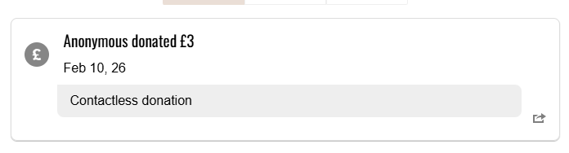
It can take up to 24 hours for a donation made via Toucan Collect to appear on your JustGiving page. The donation will appear as an anonymous donation, but with the note ‘Contactless Donation’
- What device can I use?
Toucan Collect only works with smartphones that can access the App store (Apple) or Google Play (Android).
- How do I take donations?
You can take donations via Toucan Collect anywhere you have a mobile connection by Wi-Fi or Mobile Data. Once you have connected your JustGiving page, you can choose the amount the donor would like to donate towards your fundraising by clicking ‘Collect’. An option to make a voluntary contribution will appear – the donor can decide if they would like to make this contribution or not – and then your mobile will be ready to accept the contactless donation. Donors can opt to add a small contribution on top of the donation or decide to remove.

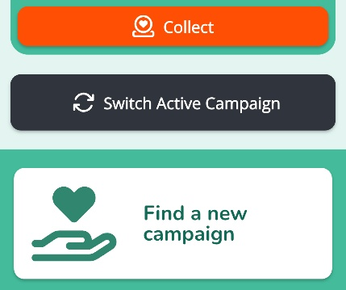
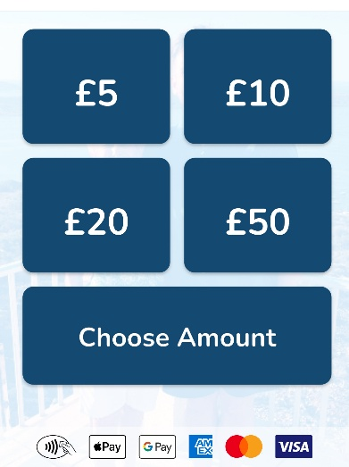
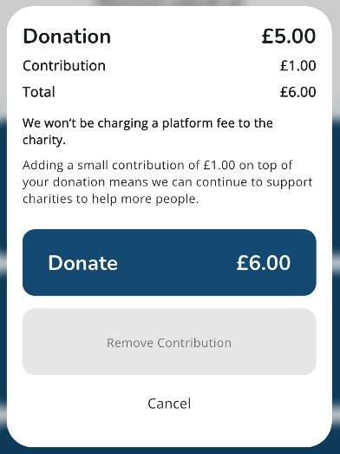

- What if I have donated to the event campaign page and not a specific fundraiser?
If you have made a contactless donation towards an event campaign page (e.g. The Big Golf Race), instead of directly onto an individual fundraising page, the donation will still make its way to Prostate Cancer UK and contribute towards The Big Golf Race. If you inform the specific fundraiser you want this donation to go towards, they will be able to add your donation to their own fundraising via an offline donation on JustGiving.
- Can I get a receipt?
Once a donation is made, scan the QR code prompt that appears to get a receipt for the donation and apply for Gift Aid if you would like to. The donation will appear as ‘JustGiving’ on your bank statement.
- What is Gift Aid?
Gift Aid is a UK government scheme allowing Prostate Cancer UK to claim an extra 25p for every £1 donated by a UK taxpayer, increasing the donation's value by 25% at no extra cost to the donor. For more information about Gift Aid, click here: https://www.gov.uk/donating-to-charity/gift-aid
- Payments not registering with your device?
It might be useful to remove any phone cases you may have, place the payment card or mobile device at the back of your phone and hold it still.
- Can I get a refund for a donation made?
Yes, you can get in touch with JustGiving via email: help@justgiving.com and they will be able to support.
- Still not connecting or having another issue with Toucan Collect?
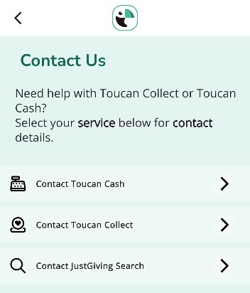
The Toucan Collect team will be available to discuss and support any issues you may have with the system. You can get in touch with their team via the settings tab in the app, under ‘Contact Toucan Collect’.

